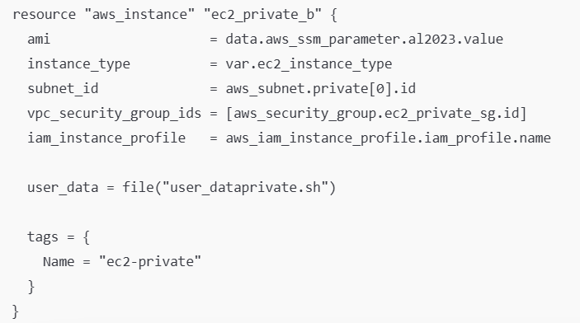
This resource creates one EC2 instance inside your private subnet (so it won’t have a public IP), and it bootstraps it at first boot using a script.
Puts the instance in your first private subnet.
Private subnet usually means:
- no public IP
- outbound internet only via NAT Gateway (if routes exist)
- inbound access typically only from inside the VPC (ALB, bastion, VPN, SSM, etc.)
Attaches the private EC2 security group
This SG decides what can connect to the instance (like ALB health checks on port 80) and what the instance can reach.

Security Group for the private app instance
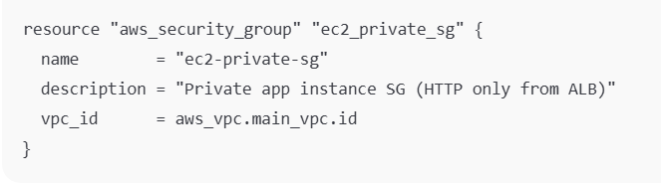

Inbound rule: allow HTTP only from the ALB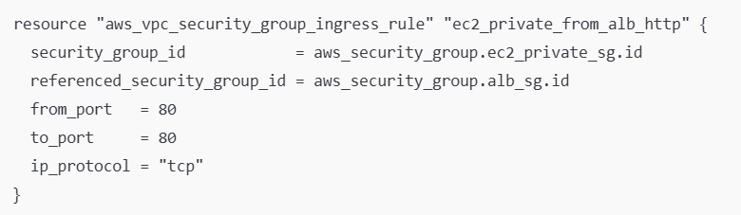
Inbound to the private EC2 is allowed on TCP 80
But only if the source is the ALB security group (alb_sg)
This is the “behind the load balancer only” pattern:
- People on the internet cannot directly hit your private EC2
- Only the ALB can reach it on port 80

Outbound rule: allow the instance to reach anything
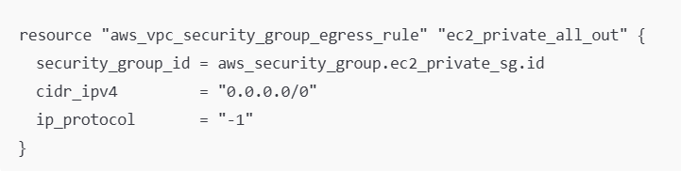
Private EC2 can send traffic out to anywhere (all ports/protocols).
This is common because outbound is usually controlled more by routing (NAT/endpoints) than SGs.

Security Group for Interface VPC Endpoints
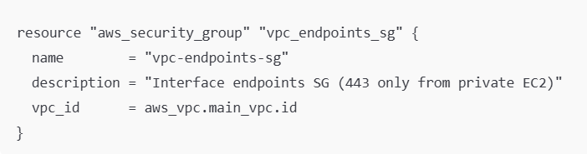
This security group is meant to be attached to Interface Endpoints (PrivateLink ENIs), like:
- com.amazonaws.<region>.ssm
- ssmmessages
- ec2messages
- secretsmanager
- logs

Inbound rule: allow HTTPS (443) from the private EC2
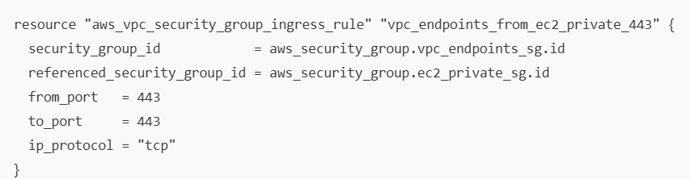
The endpoints will accept connections on 443
But only if the caller is in ec2_private_sg

Outbound rule for endpoints SG
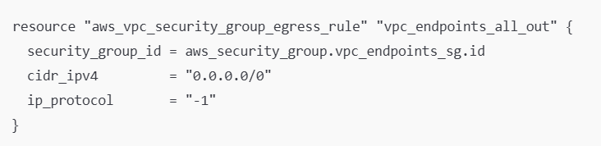
Allows those endpoint ENIs to send responses back out

Inbound rule: also allow HTTPS (443) from the “lab” EC2
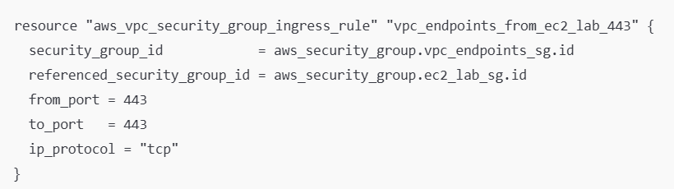
Same idea, but now your public/lab EC2 (with SG ec2_lab_sg) can also use the interface endpoints.

allow São Paulo VPC to reach private EC2 on HTTP
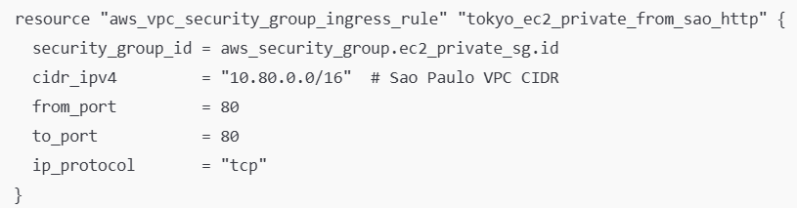
allows any IP in 10.80.0.0/16 (your São Paulo VPC) to reach the private EC2 on port 80

